**Chapter 2 – Multiple restaurants food ordering and management system**

**LITERATURE REVIEW:**

In Ancient Greece and Ancient Rome, "thermopolia" (singular thermopolium) were small restaurant-bars that offered food and drinks to customers. A typical thermopolium had little L-shaped counters in which large storage vessels were sunk, which would contain either hot or cold food. Their popularity was linked to the lack of kitchens in many dwellings and the ease with which people could purchase prepared foods. Furthermore, eating out was considered a very important aspect of socializing.

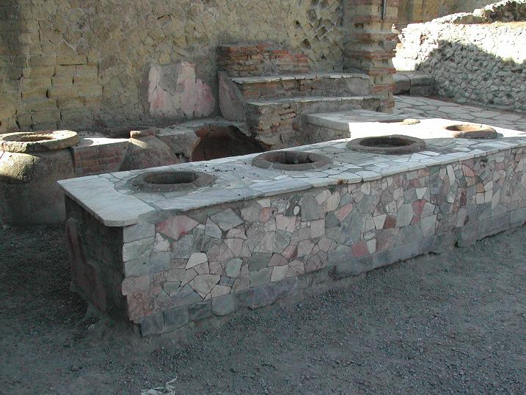

**HISTORY:**

The history of the restaurant’s development dated back into the eighteenth century to the early nineteenth century, when it became the institution that we would recognize today. The first “restaurant” was in Paris owned by a man named Boulanger who in 1765 went up against the powerful medieval catering guilds (which had a monopoly on the sale of certain food dishes) when he served a dish of sheep’s feet in white sauce in his establishment, has been debunked by modern scholarship, most notably by historian Rebecca Spang in her rich and detailed *The Invention of the Restaurant: Paris and Modern Gastronomic Culture (2000).*

A restaurant or an eatery, is a business which prepares and serves food and drinks to customers in exchange for money. Meals are generally served and eaten on the premises, but many restaurants also offer take-out and food delivery services, and some only offer take-out and delivery.

Restaurants vary greatly in appearance and offerings, including a wide variety of cuisines and service models ranging from inexpensive fast food restaurants and cafeterias to mid-priced family restaurants, to high-priced luxury establishments.

In Western countries, most mid- to high-range restaurants serve alcoholic beverages such as beer, wine and light beer. Some restaurants serve all the major meals, such as breakfast, lunch, and dinner (e.g., major fast food chains, diners, hotel restaurants, and airport restaurants). Other restaurants may only serve a single meal (e.g., a pancake house may only serve breakfast) or they may serve two meals (e.g., lunch and dinner) or even a kids' meal.

**Categories of Restaurants**

Restaurants may be classified or distinguished in many different ways. The primary factors are usually

* The food itself (e.g. vegetarian, seafood, steak)
* The cuisine (e.g. Italian, Chinese, Japanese, Indian, French, Mexican, Thai)
* The style of offering (e.g. tapas bar, a sushi train, a tastet restaurant, a buffet restaurant or a yum cha restaurant).

Beyond this, restaurants may differentiate themselves on factors including

* The speed (see fast food)
* Formality
* Location
* Cost
* Service
* Novelty themes (such as automated restaurants).

**The food**

Restaurants can be classified based of the type of food they serve. Examples are

* Vegetarian foods: These are the kind of foods that doesn't contain meats. examples includes: Rice And Beans , Quinoa , Spring Rolls , Bean-Centered Dishes, Tofu e.t.c
* Seafood: These are any form of sea life regarded as food by humans. Seafood prominently includes: fish and shellfish. Shellfish include various species of molluscs, crustaceans, and echinoderms. e.t.c
* Steak food: These are foods that consist of various kinds of meats only.

**The Cuisine**

Restaurants can be classified based on the cuisine of the food they serve. Examples are

* Italian foods
* Chinese foods
* Indian foods
* French foods
* Mexican foods
* African foods e.t.c

**The Style of offering**

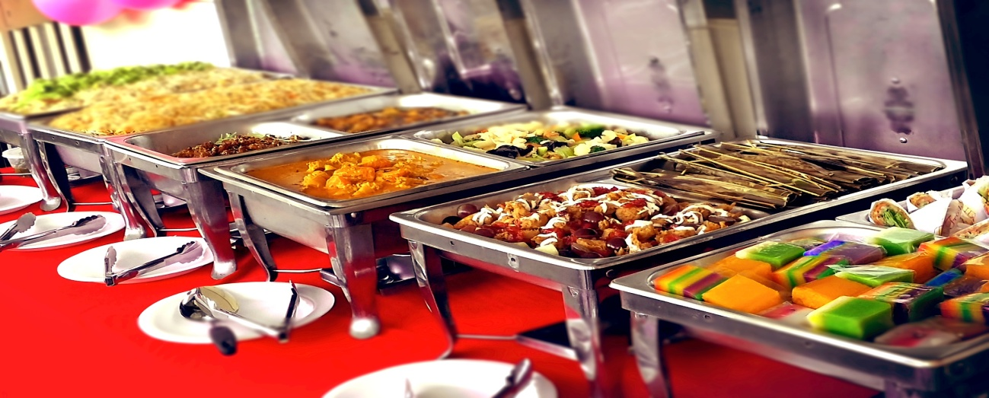

Buffet style of offering.

* Buffet restaurants: These are the type of restaurants that uses a system of serving meals in which food is placed in a public area where the diners generally serve themselves.
* Tastet restaurant: These are the type of restaurants that uses a serving style that allows for the appreciation of several flavors within a single meal. Tastet can be served as an appetizer or as a small collection for a complete meal.
  1. **Benefits of Restaurants**

Outlined are the benefits of tourism and they are highlighted that the key benefits of tourism are economic, socio-cultural and environmental (Dr.Sonya Graci , Jacqueline Kuehnel ,2003).

* **Economic benefits** - restaurants can provide direct jobs to the community, such as waiters, managers and IT personnel with good accounting skills. Indirect employment is generated through other industries such as agriculture, food production, and retail. Customers' expenditure generates income for the restaurants with is in turn paid as dues to the government and health services and serves as a source of revenue for the betterment of the economy.
* **Social benefits** - Restaurants can bring about a real sense of pride and identity to communities. By showcasing distinct characteristics of their ways of life, history and culture and uniqueness of agricultural and food products. Restaurants in a way helps to bring people together for socio-economic activities and good relationships as it serves as relaxation spots for nearby workers, tourists, business meeting points and more.
* **Environmental benefits** - Restaurants plays a vital role in the development of an environment. Presence of high number of restaurants in an area signifies high commercial activities and population which are the requirements for rapid development and serves as an attraction to potential investors and tourists.

**2.3 Classifications of Restaurants**

Restaurants can be classified into types based on their different menu styles. examples are: Automat , Cafeterias, Coffee house. e.t.c.

* + 1. **An Automat**
* An automat is a form of cafeteria-style restaurant in which simple food, usually coffee, sandwiches and other fare such as macaroni and cheese, are served to the clientele by means of vending machines.
  + 1. **Cafe Coffeehouse**
* A coffeehouse, coffee shop, or cafe shares some of the characteristics of a bar, and some of the characteristics of a restaurant. Other food may range from baked items to soups and sandwiches, other casual meals, and light desserts that complement their caffeine-centric fare.
  + 1. **Cafeteria**
* A cafeteria is a type of restaurant in which there is no table service. Instead, patrons select items that they want, placing them on a tray, and then report to a cashier to pay. As cafeterias require few employees, they are often found within a larger institution, catering to the clientele of that institution.
  + 1. **Fast Casual Restaurants**
* A fast-casual restaurant is a restaurant market niche which is a similar to a fast food restaurant in that it does not offer table service, but promises somewhat higher quality of food and atmosphere.
  + 1. **Fast-Food Restaurants**
* A fast-food restaurant is a restaurant characterised by food which is supplied quickly after ordering and by minimal service. Food purchased may or may not been eaten quickly as well. In the past five years, the industry has been trying to move the public away from the term ‘fast food’, and now prefers the term quick service restaurant
  + 1. **Greasy spoon**
* The Greasy spoon serves mainly fried food, for example, various combinations of fried eggs, chips, bacon, black puddings, sausage and mushrooms. These are often accompanied by baked beans and tomato. Other typical menu items include bacon sandwiches and toast
  + 1. **Restaurant Chain**
* A restaurant chain is a set of related restaurants, typically with the same name in many different locations either under shared corporate ownership or franchising agreements. Typically, the restaurants within a chain are built to a standard format and offer a standard menu.

**2.5 Advantage of food ordering to restaurants.** .

* It serves as a major source of income to restaurants.

**2.6 Factors that influence the establishment of restaurants**

1. Settlement: The profit of restaurants is very dependent on the population of the environment it is. Therefore more restaurants are likely to be established in an area with large population compared to a sparsely populated area. Also restaurants are attracted to areas with a larger population with "white collar" jobs as research has shown that due to employers and companies rules and policies, people with white collar jobs tend to eat more or restaurant food as there is limited time to cook.
2. Distance from market and food products : Restaurants tends seek for areas closer to the market and / or farms where they can get their food resources.

**2.7 Review of exiting systems with user modeling application for online food ordering.**

Presently there are existing modes that have been deployed to foster the level of convenience in food ordering and restaurant management. In the course of this research the internet has been observed to house most of the solutions that are presented.

In the course of this research it has been observed that there has not been much of past research being done concerning user modeling and food ordering do this research stands to be one of the first involving the use of user modeling in online food ordering and restaurant management .Also this research noticed that most systems present all deal with data collection but it must be pointed that data collection and processing is based on a different model.

In order to offer Personalized information, it is necessary to monitor a user’s behavior and to make generalizations and predictions based on these observations. Information about the user that can be drawn on in this way is called a user model. Here are some of the solutions that are available.

1. Open source: over the years open source projects of various kinds have been launched and the food ordering sector was not left out as there has been series of open source projects available.

* **Jumia foods.**

Jumia food ordering software provides open source food ordering system with easy-to-use feature it can be located at this url https://www.jumiafoods.com.ng

* **GrubHub**

This is also an online food ordering system which is designed mainly for ordering dishes online. It can be accessed at *https://www.grubhub.com/*

**2.8 SHORTCOMINGS OF EXISTING SYSTEMS**

The existing systems allhave one aim in common which is to collect data but the main concern of this research is to how is this data used to increase user experience of the systems and maximize profit on the side of the restaurant. This is based on the fact that these systems lack a model that is capable of constructing ones interest into making decisions that would increase the rate of survival of the hotel and satisfaction of the customers at the same time.

**2.9 APPLICATION OF USER MODELING TO ENHANCE HOTEL RESERVATION FOR TOURIST CONVENIENCE**

Applying user modeling in creating systems that would further make the process of food ordering more convenient can simple be described as an advanced mode of data collection with a certain level of self intelligent to make decision based on data collected .An instance is a user who inputs his or her location on a system and the system uses the location to make restaurants suggestions for the application on that particular user thereby reducing delivery time and maximizing customer satisfaction. Below is a diagrammatic expression of a user model.

Figure 1.1 An example of a user model

This is a diagrammatic expression of how a user model is related to a user. Taking consideration of the need for users to relate with an application it is highly required that users input data as it stands as one of the basic facts about computing , This diagrammatic expression explains how user modeling deals with individual data collected from a single user so as to enable the system make accurate decision .

* 1. **Conclusion**

Having gathered facts about food ordering and restaurant management, and also treating issues relating to distance and taste of the customer. It can be concluded by this research that the existing process of online food ordering provided is suitable to give a tourist a certain level of convenience, but considering the challenges that the existing system possess it would be in right condition to involve the application of a Computer science scope to find a more efficient and standard way of enhancing the level of convenience experienced by tourist while ordering food online.

In this research it is also concluded that the available modes of online food ordering lack the appropriate models.